CS 255 System Design Document

UML Diagrams

UML Use Case Diagram
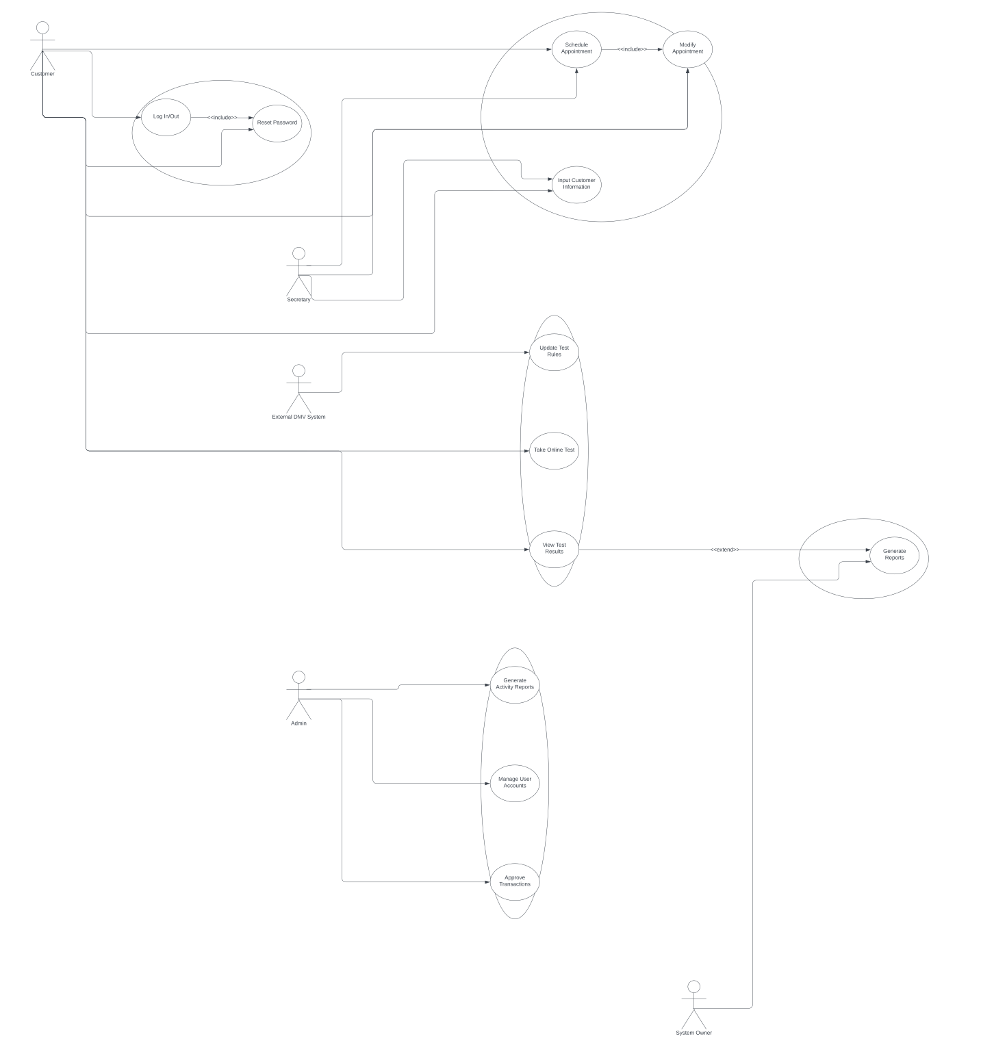

UML Activity Diagrams
Booking appointment activity diagram:
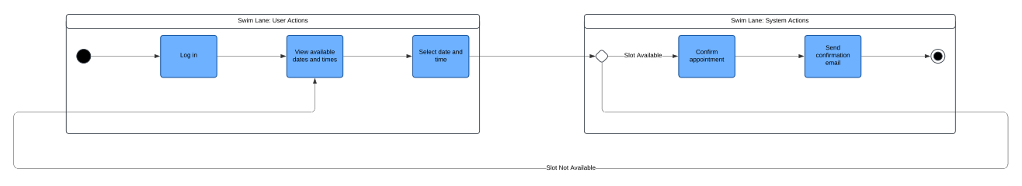

Paying for services activity diagram:
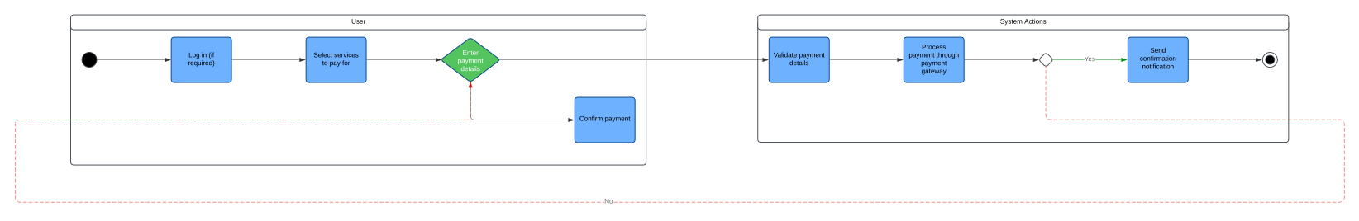

UML Sequence Diagram
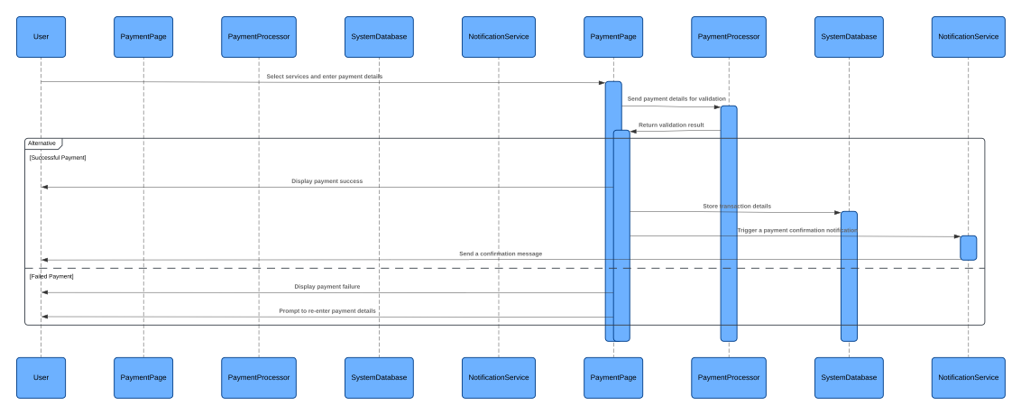

UML Class Diagram
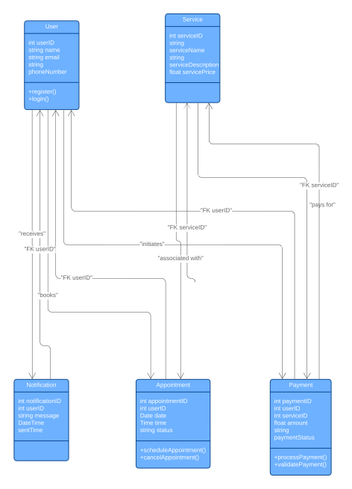

Technical Requirements

The DriverPass system will rely on a flexible, cloud-based infrastructure to ensure scalability and high availability. It will support both desktop and mobile devices, with modern browsers like Chrome, Firefox, and Safari being fully compatible. The front end will use responsive web technologies like HTML5, CSS3, and JavaScript frameworks such as React, while the back end will be powered by tools like Node.js or Django, with MySQL or PostgreSQL handling data storage. To keep everything secure, the system will use HTTPS encryption, store sensitive data using encryption protocols, and implement brute-force protection to lock accounts after multiple failed login attempts. It will integrate with DMV systems via APIs for real-time updates and leverage third-party services like Stripe or PayPal for secure payment processing. Additionally, an admin dashboard will allow IT staff to manage user roles, reset passwords, and monitor system activity without needing code changes. With scheduled backups and a disaster recovery plan in place, the system will prioritize data security and reliability. Although it requires a constant internet connection and may face minor limitations with slower networks, this setup ensures a smooth, efficient experience for all users.

